|  |
| --- |
| ABOUT THE INSTITUTION |

S.A. Engineering College (Autonomous) was established by Dharma Naidu Educational and charitable trust in the year 1998-1999. The college is approved by AICTE, Delhi and approved by Anna University Chennai. The college is well equipped with 5 lakhs sq.ft. of constructed area which includes class rooms, drawing halls, laboratories, workshops and associated facilities. In recognition of the high quality policies being implemented by the institution M/S TUV NORD has accorded ISO 9001-2015 certification. All the undergraduate programs are accredited by the National Board of Accreditation (NBA), Delhi and NAAC certified with 'A' grade. The college offers following 6 U.G programmes and 6 P.G programmes.

B.E. - Civil Engineering

B.E. - Computer Science and Engineering

B.E. - Electronics and Communication Engineering

B.E. - Electrical and Electronics Engineering

B.E. - Mechanical Engineering

B.Tech. - Information Technology

M.E. - CAD/CAM

M.E. - Communication Systems

M.E. - Computer Science and Engineering M.E. - Embedded System Technologies M.B.A. - Master of Business Administration M.C.A. - Master of Computer Applications.

The college maintains high standards of education by providing a wide array of world class academic facilities, employing highly qualified and experienced faculty members and creating an ambience of conductive quality education.

FOUNDER :

(Late) Shri. D. SUDHARSSANAM

CHIEF PATRONS :

Shri. D. DURAISWAMY, Chairman

Shri. D. PARANTHAMAN, Vice Chairman

Shri. D. DASARATHAN, Secretary

Shri. S. AMARNAATH, Correspondent Shri. S. GOPINATH, Joint Secretary

PATRON :

Shri. D. SABARINATH, Director

CO-PATRON :

Dr. G.S. KUMARASAMY, M.E., Ph.D., Principal

CONVENOR :

Dr. R. GEETHA, Ph.D., Professor and Head / CSE

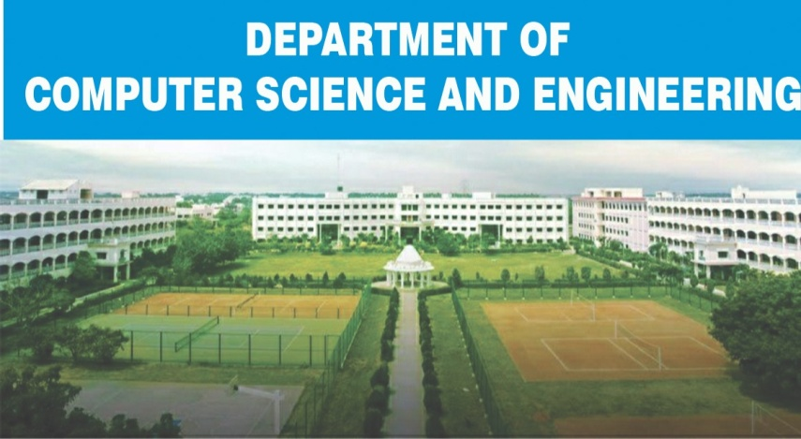CO-CONVENOR :

Dr. S. VEENA, Ph.D.,

Professor /CSE

ORGANIZING COMMITTEE :

Dr. M. PREETHA, Assoc. Prof / CSE

Mr. C. BALAKRISHNAN, Assoc. Prof / CSE

Mr. M. BALASUBRAMANIAN, Assoc. Prof/CSE

Mrs. N.S. USHA, Assoc. Prof / CSE

Mr. A. MANI, Assoc. Prof / CSE

Mrs. D. VINODHA, Assoc. Prof / CSE

Mr. S. MUTHUKUMARASAMY, Assoc. Prof/CSE

# PHASES OF STTP

Last Date for Phase 1 Registration . 12.112020 Last Date for Phase 2 Registration . 26.11.2020

Last Date for Phase 3 Registration . 10.12.2020

Phase 1 - 16.11.2020 to 21.11.2020

Phase 2 - 30.11.2020 to 05.12.2020 Phase 3 - 14.12.2020 to 19.12.2020

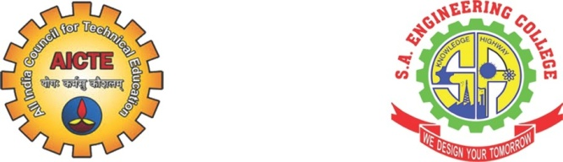

# AICTE

Sponsored STTP

on

"Demystifying BlockChain

Technology & Cyber Security

Threats : Issues and Challenges"

Organised by

## S,A, ENGINEERING COLLEGE

(An Autonomous Institution, Affiliated to Anna University)

Accredited by NBA, NAAC with 'A' Grade &

ISO 9001 : 2015 Certified Institution

Poonamallee - Avadi Main Road,

Thiruverkadu, Chennai- 600 077.

Phone : 044-2680 1999, 2680 1499

Fax : 044-2680 1899 www.saec.ac.in

### ABOUT THE STTP

Blockchain Technology is decentralized, immutable data storage and management technology built by leveraging the idea of distributed, consensus ledger. This public ledger approach with verifiability using hash sequences makes block chains a trustworthy collaborative platform. This technology enables the people with no confidence in each other to collaborate without the need of trusted third party. The utility of this collaborating platform is largely dependent on smart contract technology which executes contractual agreements between collaborating entities. Many corporate companies and startups have already started investing in this compelling opportunity and a few innovative products and services have already surfaced in this area. Cyber security is another promising area that encounters the security breaches. The blockchain technology can work from cyber risk perspective. The potential application of block chains in various business domains like banking, supply chain, financial services, asset registry, inventory, identity management, healthcare, insurance, public notary etc.

|  |
| --- |
| ABOUT THE DEPARTMENT |

The Department of Computer Science and Engineering has dedicated and specialized faculty members in different areas with rich experience in academics, industry and research. The department has excellent class rooms equipped with modern audio-video aids, tutorial/seminar halls, library and spacious research and development labs with latest configurations. The department also has CISCO networking lab sponsored by AICTE MODROBS and 10T lab by INTEL.

#### PROGRAMME OUTCOMES

At the end of the programme the audience and the future developers who are involved in technological transformation will be able to :

* Explain how blockchain technology works • Integrate blockchain technology into the current business processes to make them secure

|  |
| --- |
| COURSE CONTENTS |

* Basics of Blockchain and Cryptocurrencies
* Layers and structure of Block Chain
* Blockchain Platforms and Applications
* Limitations, Opportunities, Challenges of

Blockchain

* Designing Blockchain
* Consensus Algorithms
* Ethereum Smart Contracts
* Blockchain and Graph Databases  Developing Blockchain towards interdisciplinary applications  Cyber threats and attacks
* Cyber Crime and Cyber terrorism
* Cyber Crime Cases (Past, present & future)
* Mobile Hacking & Security
* Vulnerability Scanning in Websites  Advanced Cyber threats
* DDOS attack and traceback system
* Security of Blockchain Technology  How blockchain technology works from cyber risk perspective
* Tensions between using blockchain technology and data privacy obligations  Cyber security usecases for block chain technology

#### RESOURCE PERSONS

Resource persons from premier Research, Academic Institution and Industry will deliver the lectures and conduct practical sessions.

|  |
| --- |
| SESSION SCHEDULE |

FORENOON 10.00 AM to 12.00 PM

AFTERNOON : 02.00 PM to 04.00 PM

|  |
| --- |
| CERTIFICATE |

E-certificate will be awarded to the participants attending the program and scoring minimum 60% marks in the test that will be conducted at the end of each phase of the STTP

|  |
| --- |
| REGISTRATION DETAILS |

Registration Fee: No Fee Registration Link :

https://forms.gle/M3WiUMaaYevnmeQm6 Note : Participants can register for only one phase

|  |
| --- |
| ADDRESS FOR CORRESPONDENCE |

##### Dr. M. PREETHA, Ph.D.,

Co-ordinator

Short Term Training Programme on "Demystifying BlockChain Technology &

Cyber Security Threats: Issues and

Challenges"

##### S.A.ENGINEERING COLLEGE

(Autonomous)

Poonamallee - Avadi Main Road,

Thiruverkadu, Chennai-77

Email Id : csedept@saec.ac.in

Ph : 9443839811

        <!-- ======= Suscribe Section ======= -->

        <div class="suscribe-area">

            <div class="container">

                <div class="row">

                    <div class="col-lg-12 col-md-12 col-sm-12 col-xs=12">

                        <div class="suscribe-text text-center">

                            <h3>Welcome to our eBusiness company</h3>

                            <a class="sus-btn" href="#">Get A quate</a>

                        </div>

                    </div>

                </div>

            </div>

        </div>

        <!-- End Suscribe Section -->